ARCH 6011 URBAN DESIGN LABORATORY Professor Ellen Dunham-Jones

FALL 2017 Arch West 355 – hrs by aptmt.

edj@gatech.edu

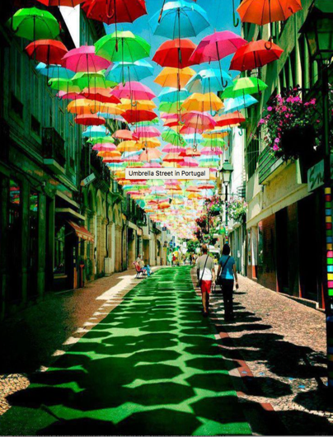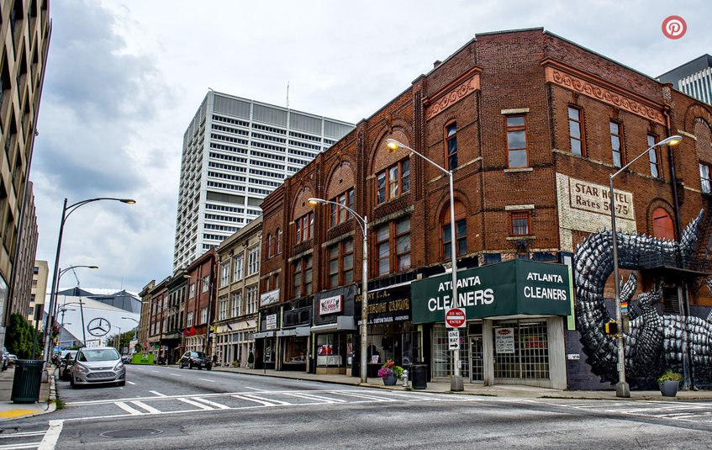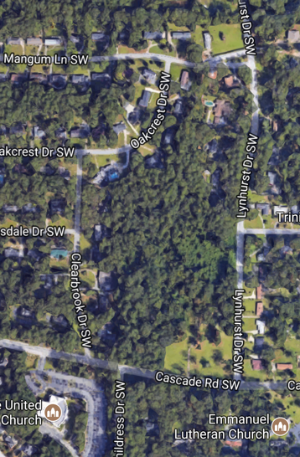

PUBLIC REALM ADDITIONS/PRIVATE REALM subDIVISIONS

The City of Atlanta is sponsoring this 2-part introductory studio in the MS Urban Design program. The first 9 weeks will be focused on improvements to the public realm of South Downtown and the Government District. Poised for huge private investments, (the first in nearly a century,) how can the area’s neglected public realm encourage creative renewal and collaboration on a shared future? Pairs of students will prepare plans and mock-ups for immediate implementation on various “gateway” and other strategic sites in consultation with the City’s Planning & Public Works Departments, MARTA, Central Atlanta Progress, the Center for Civic Innovation, Newport US RE, and other stakeholders. The projects will range from temporary tactical urbanist parklets to demonstration pilot projects. Research will focus on three topics: placemaking & building social capital; curb management– especially relative to carhailing and autonomous vehicles; and eco-infrastructure & urban heat island. Integrating their interventions with the life and conditions of the street, students will also prepare plans for redesigning excess right-of-way and streetscaping the block fronts adjacent to their projects.

The second project moves out to the city’s southwest suburbs and tackles the question: how can infill properties in residential neighborhoods be subdivided and developed to both introduce new amenities, connectivity, building types, uses, and higher density while protecting the city’s beloved tree canopy? In the process, students will learn the fundamentals of platting new streets, blocks, and lots while working with topography, drainage, and preserving trees. Students will re-plat the largely tree-covered site at the intersection of Lynhurst Drive and Cascade Road and propose a range of possible development scenarios for both community feedback and to inform the City of Atlanta’s City Design Project and rezoning recommendations.

Workshops – all are welcome: 8/25 – Streets; 9/1 – Parklets; 9/8 – RD: 10 Lessons; 9/22 - RD: /Water; 9/29 – Public Spaces, 10/20 – RD Topography & Grading, 10/27 – Blocks, Lots & Parking

Learning Objectives

This is the first in the sequence of urban design studios for the Master of Science in Urban Design Program. Students will have the opportunity to work both individually and in teams so as to engage a multiplicity of perspectives and disciplinary knowledge.

The studio has five primary learning objectives:

First, to introduce the core dimensional knowledge that is unique to the discipline of urban design. This is accomplished through field measurements, literature analysis, and speculative testing of:

* urban morphology - how territory is organized and how property is subdivided into lots, blocks, and streets
* the dimension and design of different kinds of streets and public spaces
* the dimension, design and regulation of the private domain with new or conventional building typologies.

This knowledge is demonstrated through the production of regulatory and illustrative plans.

Second, to equip students with a basic level of technical knowledge necessary for urban design practice and creative speculation. This includes analytical work necessary for identifying and communicating existing situations & issues, assets and liabilities and producing design proposals and proposals for their implementation that integrate various infrastructures, activities, to improve the public realm.

Third, to build communication and media skills for urban design projects and practices to communicate graphically and verbally with each other, to other disciplines, and to the public.

Fourth, to build critical thinking skills relative to the societal impacts and performance of urban designs in relation to contemporary challenges. Students will be expected to make convincing quantitative and qualitative arguments justifying their proposals. This studio will specifically be focused on the challenges of: placemaking and building social capital; curb management and streetscaping; eco-infrastructure and urban heat island; and strategic protection of trees during suburban infill and densification.

Workshop lectures on occasional Fridays and field trips will help build these skills as will production of collective final reports for the city of both projects.

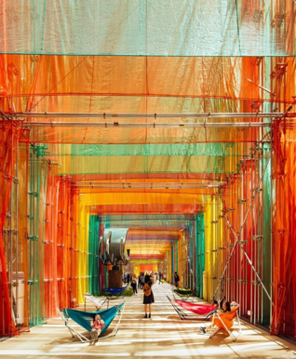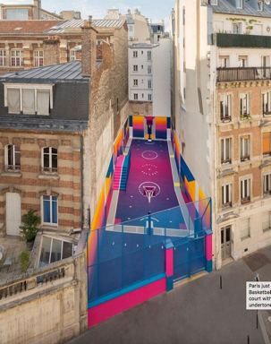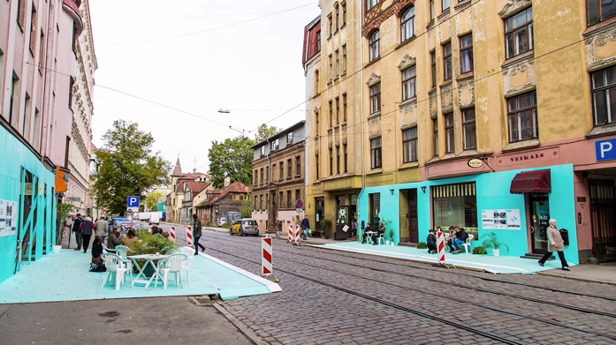

Project 1: Public Realm Additions

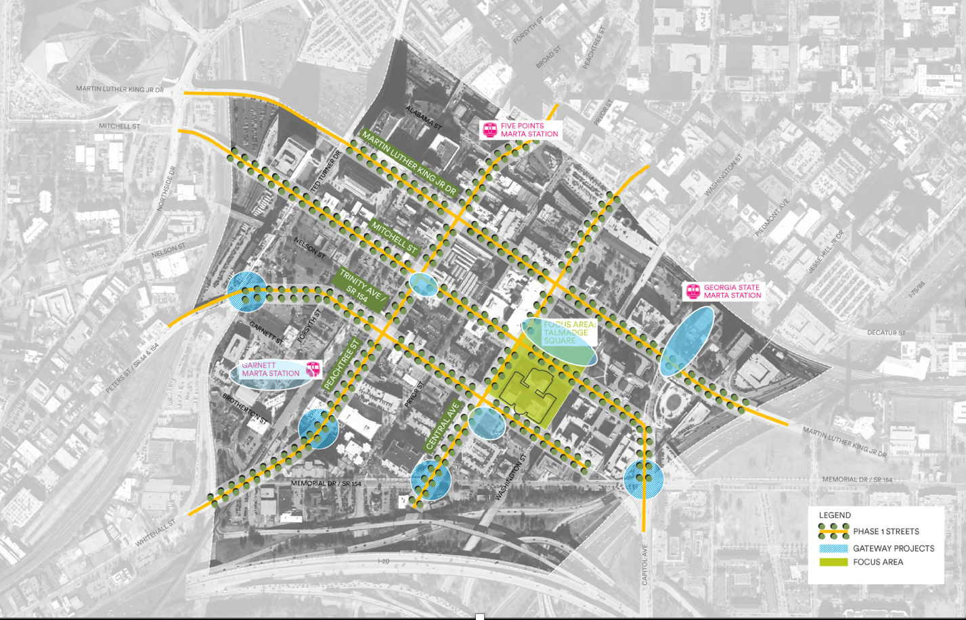Students will work in two-person teams. Each team will produce proposals for two sites.

“Sites Teams” - four of the teams will be assigned specific “gateway” sites to work on and research the most appropriate strategies for:

* GSU MARTA Station + Capitol Ave and Memorial Drive intersection lid
* Talmadge Plaza + SE corner of Mitchell and Peachtree
* Green at SE corner of Central & Trinity + Central Avenue, Memorial Drive and Pulliam St
* Garnett MARTA Station + Ted Turner Drive, Peters St, and Fire Station No 5 Park

“Topics Teams” – three of the teams will be assigned specific topics to research and then find appropriate sites for:

* Curb Management and Streetscaping
* Placemaking and Building Social Capital
* Eco-Infrastructure and Urban Heat Island

Each team will identify simple “fixes” for each site - such as removal of broken fences or new plantings to replace dead trees or shrubs. Each team will also propose an immediate “tactical urbanist” intervention for one of their sites and a more substantial pilot project/intervention for their other site. Each team will also propose permanent improvements to the streets adjacent to their site in the form of road diets, street trees, paving and other recommendations. In addition to drawing up these individual proposals, each team will insert their designs into a collective masterplan and final report for the city.

Both Sites and Topics teams will research precedents in public realm improvements inclusive, but also beyond the focal topics. Topics to be considered include:

Complete Streets: taming cars, going multi-modal

* Road diet: remove drive lanes, narrow drive lanes
* Traffic calming
  + Bollards, weaves, shared space…
* bike lanes
* bike share stations
* missing crosswalks
* curb management: on-street parking, deliveries, PUDOs, disability mobility, bike racks/bike lanes
* pavement to plazas
* curb cuts/accessibility
* pilot project: Pick-up/Drop off station network promoting shared rides?

Eco Infrastructure: stormwater management, reducing urban heat island

* Street trees – guerrilla gardening
* Bio-swales
* Pervious pavement, solar pavement
* Edible landscaping, composting stations
* Green walls
* Light-colored surfaces
* Renewable energy infrastructure??
* Resilience/disaster recovery
* Wildlife habitat
  + Pollinators at parking lots
  + gardens
* Pilot project: geothermal under the streets??
* Pilot project: new uses for captured air conditioning condensate?

Streetscaping: celebrating the public realm, streets as safe, attractive people places

* Water features
* Decorative plantings
* Street furnishings
* Public art, murals
* Lighting
* Wayfinding
* Better Bus stops/PUDOs
* Recommendations for pedestrian-friendly building frontages
* Pilot project: Atlanta history/character mural or branding…?

Placemaking: Multi-activity: places to linger, eat lunch, play, be social, build social capital, be inspired

* Stakeholder input
* Urban living room, shared amenities, shared activities, shared resources
  + Liner buildings to shape public spaces, screen pkg
* Seating, micro-cafes,
* Performance “stages”, soapbox platforms
* democratic expression
* local identity
  + The Beloved Community
  + City in the Forest
* Parklets, pocket parks, dog parks
* Food trucks, vendors
* Things to do while waiting: games, swings, music..
* Places for kids
* Wifi hotspots
* Public showers, restrooms
* Beauty and belonging for all
* Night uses: parking lots transformed to night markets, b’ball/tennis courts, skate rinks?
* Pilot Project: seasonal alterations to add cooling in summer and warming in winter
* Pilot Project: shared space/temporary festival space/beach

Smart City

* Robot delivery
* Manage waste as food
* Managed truck delivery
* Managed parking
* Traffic management
* Tidy Street Project?? Usage
* Estimate revenue from VMT usage?
* New modes of sharing
  + Shared umbrellas
  + Shared rides
  + Shared tools
  + Shared
* Pilot project: Autonomous Rapid Transit dedicated lane route??
* Pilot project: data kiosks?

Schedule (subject to revision)

Project 1: Streets and the Public Realm

Week 1: Aug 21 – **Kick-off and Research**

* M: 12:00 set up studio, hand out syllabus
* M: 1:00 SOLAR ECLIPSE at GT Campanile
* M: 5:00 Studio Lottery in CoD auditorium to learn about other studios
* W: 1:25 Grad Welcome, Hinman main studio space
* W: 2:00 Heather Alhadeff (City of Atlanta) will present the city’s goals, Kevin Bacon (Atlanta City Studio) will present P+W’s work on the Government District, Blake Reeves (MSUD/P+W) will present his public space survey, followed by group discussion. Assign sites & topics to pairs of students.
* F: Workshop: Streets

Week 2: Aug 28 – **Defining the Problem**

* M: **site visit 1**: Review new Downtown Plan at Central Atlanta Progress, walk sites with Jennifer Ball (CAP). Observe positives and negatives, potential excess r.o.w., Topics students identify tentative sites.
* W: **Pin-up: “what’s the problem?”:** Present research on precedents, topics and sites, identifying problems and possible solutions. Group brainstorm w invited guests on short & long-term projects.
* F: Workshop: Parklets with Wesley Brown (CAP)

Week 3. Sept 4 – **Site documentation**

* M: *Labor Day Holiday*
* W: **site visit 2**: document/measure “the problem”, document dimensions, adjacent buildings, infrastructure, activities, talk with occupants
* F: workshop: Dagenhart – Ten Lessons on Urban Design

Week 4. Sept 11 **Pin-Up & Parklets**, Smart Cities Week events

* M: **“The What & Why”** **Pin-Up**: proposals, precedents, means of implementation, means of soliciting feedback with the parklet
* W: parklet design workshop
* W: 5:30 – Downtown Atlanta Master Plan presentation at Atlanta Central Library
* Th: North Ave Smart Corridor Launch
* F: **Parklet Installations** for (Park)ing Day

Week 5. Sept 18 **Detail Design**

* M: desk crits: MARTA sites and Curbs
* W: desk crits: Gateway sites & Eco, & Social Capital
* F: Workshop: Dagenhart - Water

Week 6. Sept 25 –**Implementation Partners**

* M:desk crits
* W: **Implementation Partner Pin-up** with representatives from City of Atlanta, MARTA, CAP, Newport, Center for Civic Innovation, Lyft, etc.
* F: Workshop: Public Spaces

Week 7. Oct 2 - **The Big Picture: putting the improvements into context**

* M:Desk crits
* W: Desk crits
* F: Assemble collective base plan & powerpoint.

Week 8. Oct 9 **Final Production**

* M: *Fall Break Holiday*
* W: EcoDistricts Summit
* F: Work

Week 9. Oct 16 **Final presentation**

* **M: Final Review 10-5**

**Project 2: Blocks & Lots: Suburban Mixed-Use Redevelopment at LynHurst & Cascade**

* W: no class – catch up on everything else!
* F: Workshop: Dagenhart: Topo and Grading (EDJ out of town)

Week 10: Oct 23

* M: **Site Visit** and Debrief with Heather Alhadeff (City of Atlanta) and arborist
* W: **Field Trip: Vickery, Cumming GA**
* F: Workshop: Urban Dimensions

Week 11: Oct 30

* M: Desk crits
* W: **Pin-Up:** Site analysis, building type & lot analysis, preliminary subdivision proposal with and without protecting trees
* F: Workshop: Regulating and Illustrative plans

Week 12: Nov 6

* M: desk crits
* W: **Pin-Up:** regulating plan with tree protection recommendations, illustrative plan
* F: work

Week 13: Nov 13 **Final Production**

* M: desk crits
* W: desk crits
* F: EDJ out of town
* Sat Nov 18: **Final Review**

Week 14: Nov 20 **Start Report Production, Thanksgiving Holiday**

* M: Workshop: team production of final reports
* W: Thanksgiving Holiday – no class
* F: Thanksgiving holiday – no class

Week 15: Nov 27 **Final Report**

* M: Teams work on final reports
* W: Teams work on final reports
* F: Submit final report, M.Arch Portfolio Party Day

Week 16: Dec 4 **Clean Up**

* M: All-studios clean-up day

Requirements

Attendance is required Monday and Wednesday from 1:25-6:25 and Friday from 1:25-3 for SoA lectures or team-work and from 3-5 for workshops as noted in the schedule. Classes will typically start with a group discussion and announcements PROMPTLY at 1:25. Students are responsible for determining what they missed if they arrive late. Missing three classes, excused or unexcused absence will result in an automatic drop of a letter grade. Missing more than three classes will result in a meeting with the Instructor and the School of Architecture office and may result in failure of the class.

The studio demands considerable additional work time outside of class. Students are strongly encouraged to work in the studio space, to collaborate with each other, and contribute to a positive and respectful studio culture.

The studio encourages teamwork, collaboration, and the study of precedents. This is to result in expanding the individual student’s skillsets and knowledge. However, students must acknowledge the sources of all work that is not their own. Direct copying of other’s ideas, words, or forms without attribution is plagiarism and is not allowed.

Attendance at the School of Architecture Friday afternoon lecture series is considered part of the class requirement.

All work produced in relation to a grade is considered the property of Georgia Tech and is to be submitted in the requested pdf and tiff formats before the conclusion of the semester.

Students with disabilities who need to request classroom accommodations should complete the GT Accommodate process, <http://disabilityservices.gatech.edu/content/welcome-accommodate>.

In case of emergency (i.e. fire, accident, crime, etc.) please call the Georgia Tech Police at 404 894 2500. Please note that Perry Minyard, IT Support Administrator is a firefighter and Emergency Medical Technician certified in performing CPR.

Academic Integrity and Conduct

Georgia Tech aims to cultivate a community based on trust, academic integrity, and honor. Students are expected to act according to the highest ethical standards. All Georgia Tech students should familiarize themselves with and abide by the Georgia Tech Honor Code <http://www.catalog.gatech.edu/rules/18/>. Student work that presents the ideas or words of others as the student’s own adversely impacts the whole school and may lead to immediate dismissal. Academic dishonesty, including cheating, plagiarism, commissioning academic work by others, or performing academic work on behalf of another student, is strictly prohibited. All persons in the classroom are expected to behave with courtesy towards others and in a way that does not interfere with the regular conduct of the class. Cell phones are to be turned off when students enter the classroom and should remain off for the duration of class: <http://www.catalog.gatech.edu/rules/19/>

Grades

Students will be evaluated on their individual performance, even though much of the work will be done in teams. Grading is at the discretion of the instructor. Effort, evidence of growth and learning, and collaboration with others will constitute half of the grade. The other half will be based on the production of work that is well-researched, coherent, complete, and inspiring.

* A grade of “A” means that the student has clearly understood the aims of the studio and been self-motivated to exceed them with exceptionally good work.
* A grade of “B” means that the student has met the requirements, has consistently advanced the work with good attention to the criteria.
* A grade of “C” means that the student has satisfactorily met only the minimum requirements for the studio, the work is undeveloped and/or does not reflect a consistent and adequate effort.
* A grade of “D” reflects significant attendance problems, unsatisfactory work and failure to meet a significant number of the requirements of the studio. A grade of “D” means the studio must be repeated.
* A grade of “F” means failure to meet almost all of the studio requirements and requires that the studio must be repeated.